

**Golden-Gate Int’l College**

Affiliated to Tribhuvan University

Old Baneswor, Kathmandu

**A**

**Lab Report on**

**Mobile Programming**

**(CACS 351)**

**Lab Title: CRUD Application**

**Lab Sheet No: 3**

|  |  |
| --- | --- |
| **Submitted by:** | **Submitted to:** |
| Name: Surakshya Lama | Mr. Deepak Thakur |
| Roll no:15 | Submission date: 11th May, 2025 |
| Registration no:6-2-453-15-2021 |  |

1. **Write android program to create a small CRUD Application(P/H)**
   1. **Application must have menu (insert data, display data).**
   2. **Data should be store in MYSQL server.**
   3. **Display data in list view.**
   4. **When list item is clicked detail of item should be display in dialog box.**
   5. **When list item is long pressed it should display context menu for delete and update.**
   6. **When update is selected than the detail of list item should be display in another fragment for update.**

**PHP files:**

db.php:

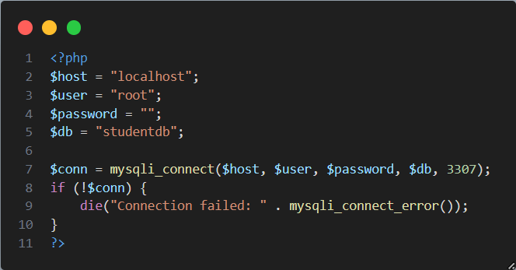

insert.php:

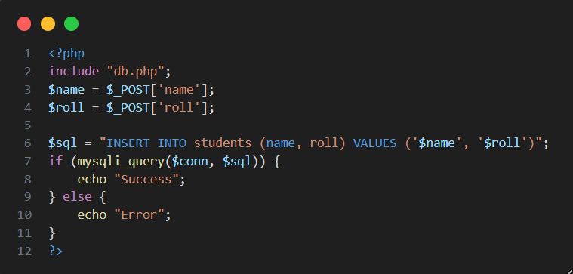

update.php:

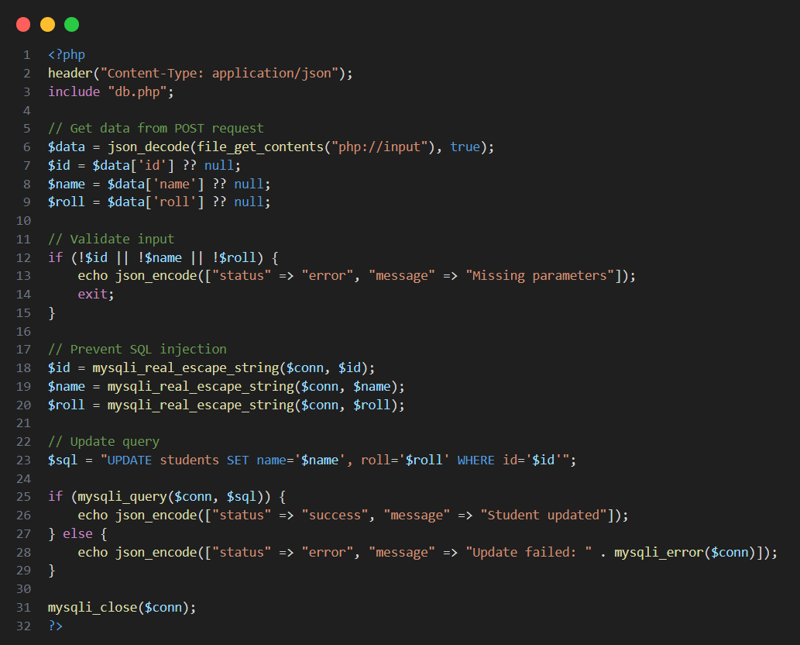

fetch.php:

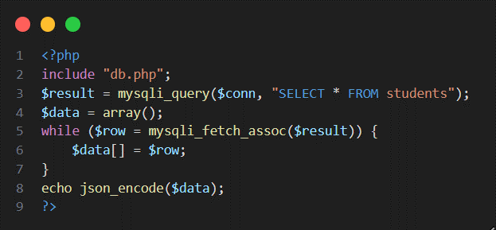

delete.php:

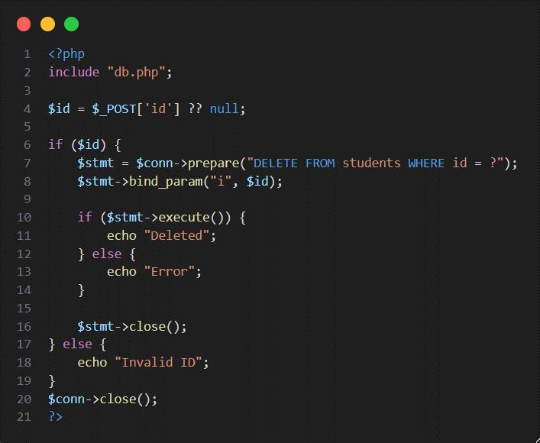

**Menu files:**

main.xml:

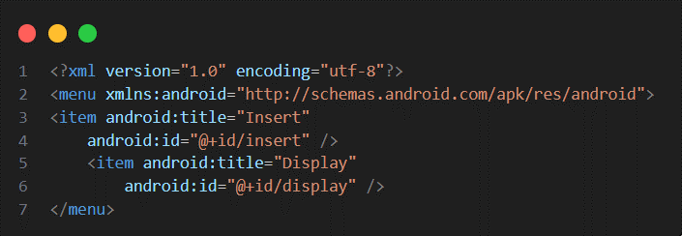

main2.xml:

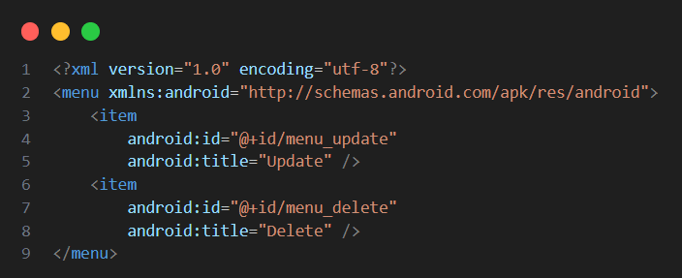

**Layout files:**

layout.xml:

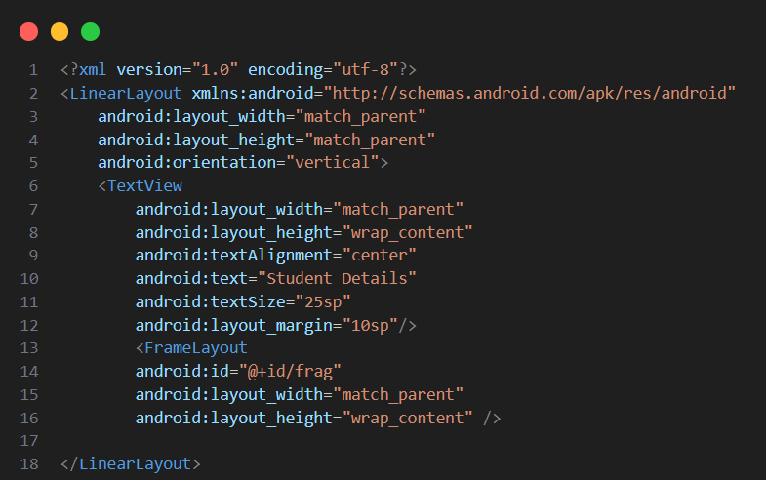

fragment_insert.xml:

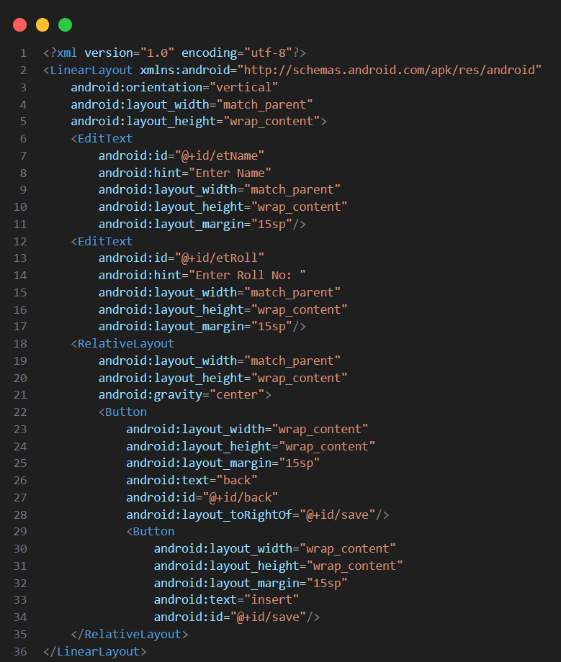

fragment_display.xml:

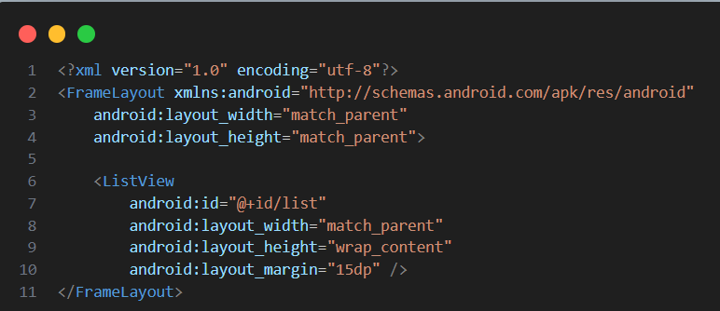

fragment_update.xml:

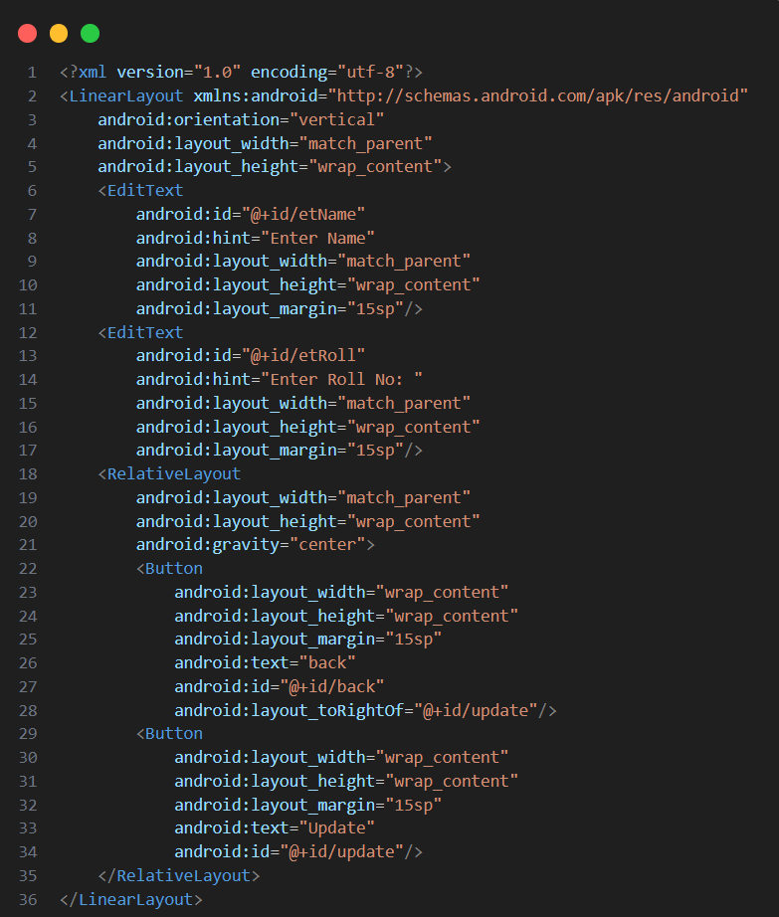

display_list.xml:

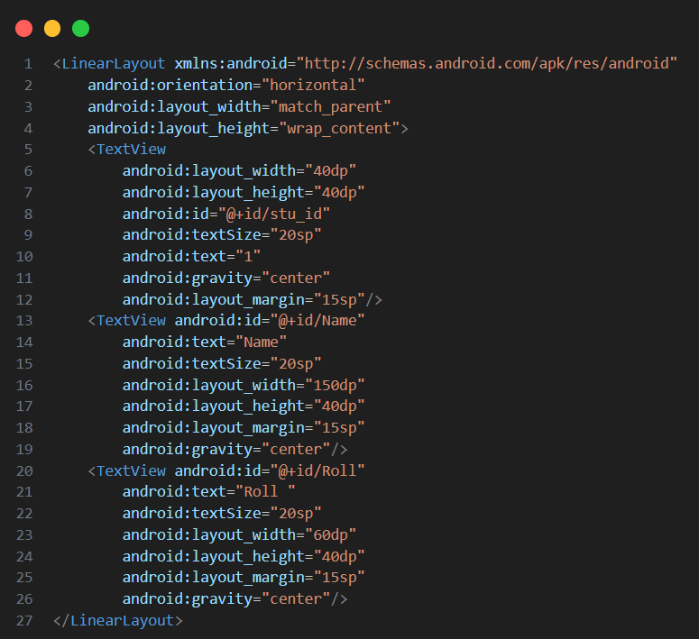

**Java files:**

Student.java:

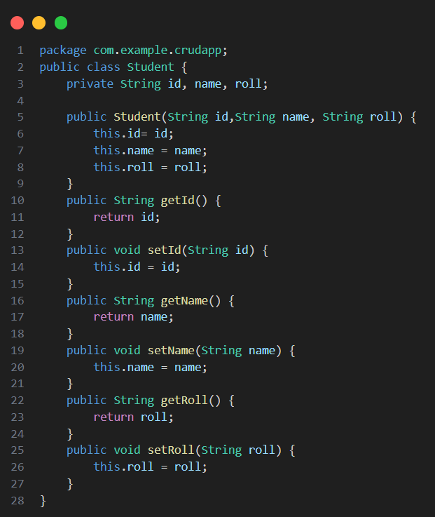

insert.java:

display.java:

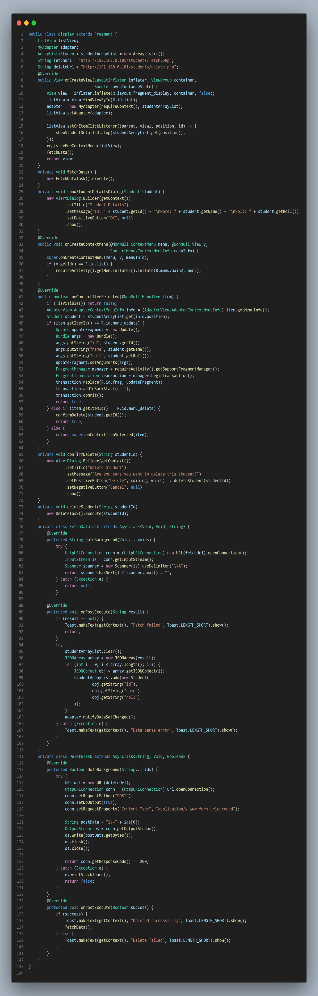

MyAdapter.java:

MainActivity.java:

Update.java:

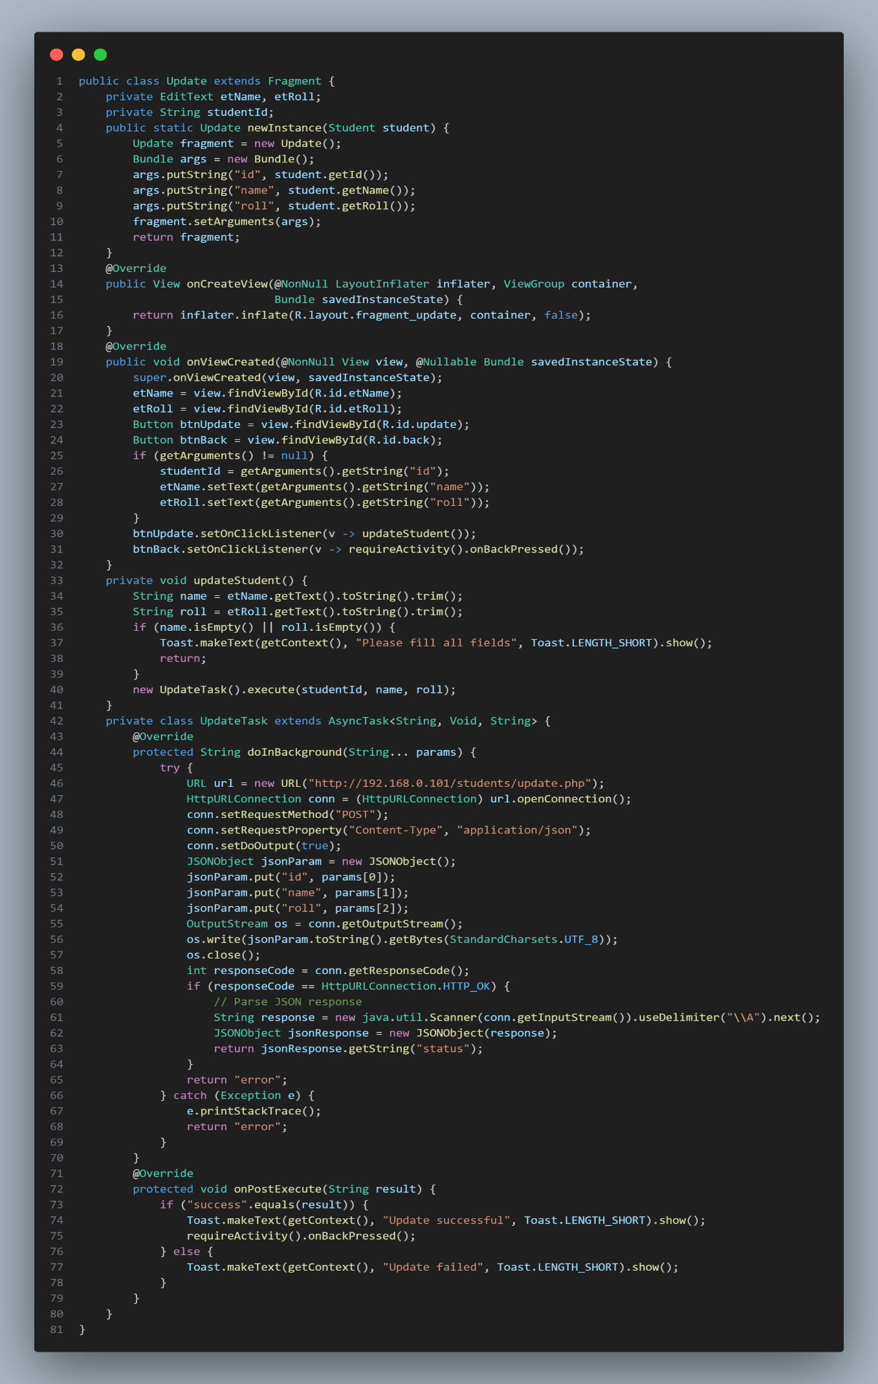

Output:

|  |  |
| --- | --- |
| Entry Screen: | Display Screen with Insert Function: |
| Display Screen with Insert Function: | Display Screen with Display Function: |

|  |  |
| --- | --- |
| Display Screen with Update & Delete Function: | Display Screen with Update Function: |
| Display Screen After Updating: | Display Screen with Update & Delete Function: |

|  |  |
| --- | --- |
| Display Screen with Delete Dialog Box: | Display Screen After Deletion: |
| Display Screen with Detail Dialog Box: |  |